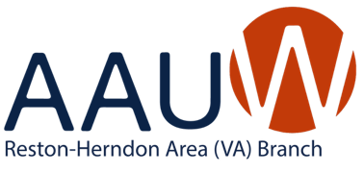

**2024 – 2025:** **AAUW RESTON ~ HERNDON AREA BOARD OF DIRECTORS**

**Elected Positions**

**President:** Janine Greenwood

**Treasurer:** Ruth Ruttenberg

**Secretary:** Stephanie Abbott

**Appointed Positions**

**AAUW Funds:** Stephanie Abbott

**Book Group:** Alyse Goldman and Carla Heymsfeld

**Cultural Arts:** Carol Flicker and Joyce Senger

**Diversity, Equity, Inclusion & Belonging**: Patty Hagan

**Newsletter:** Open

**Public Policy:** Shyamali Hauth

**Website Manager:** Samantha Polon