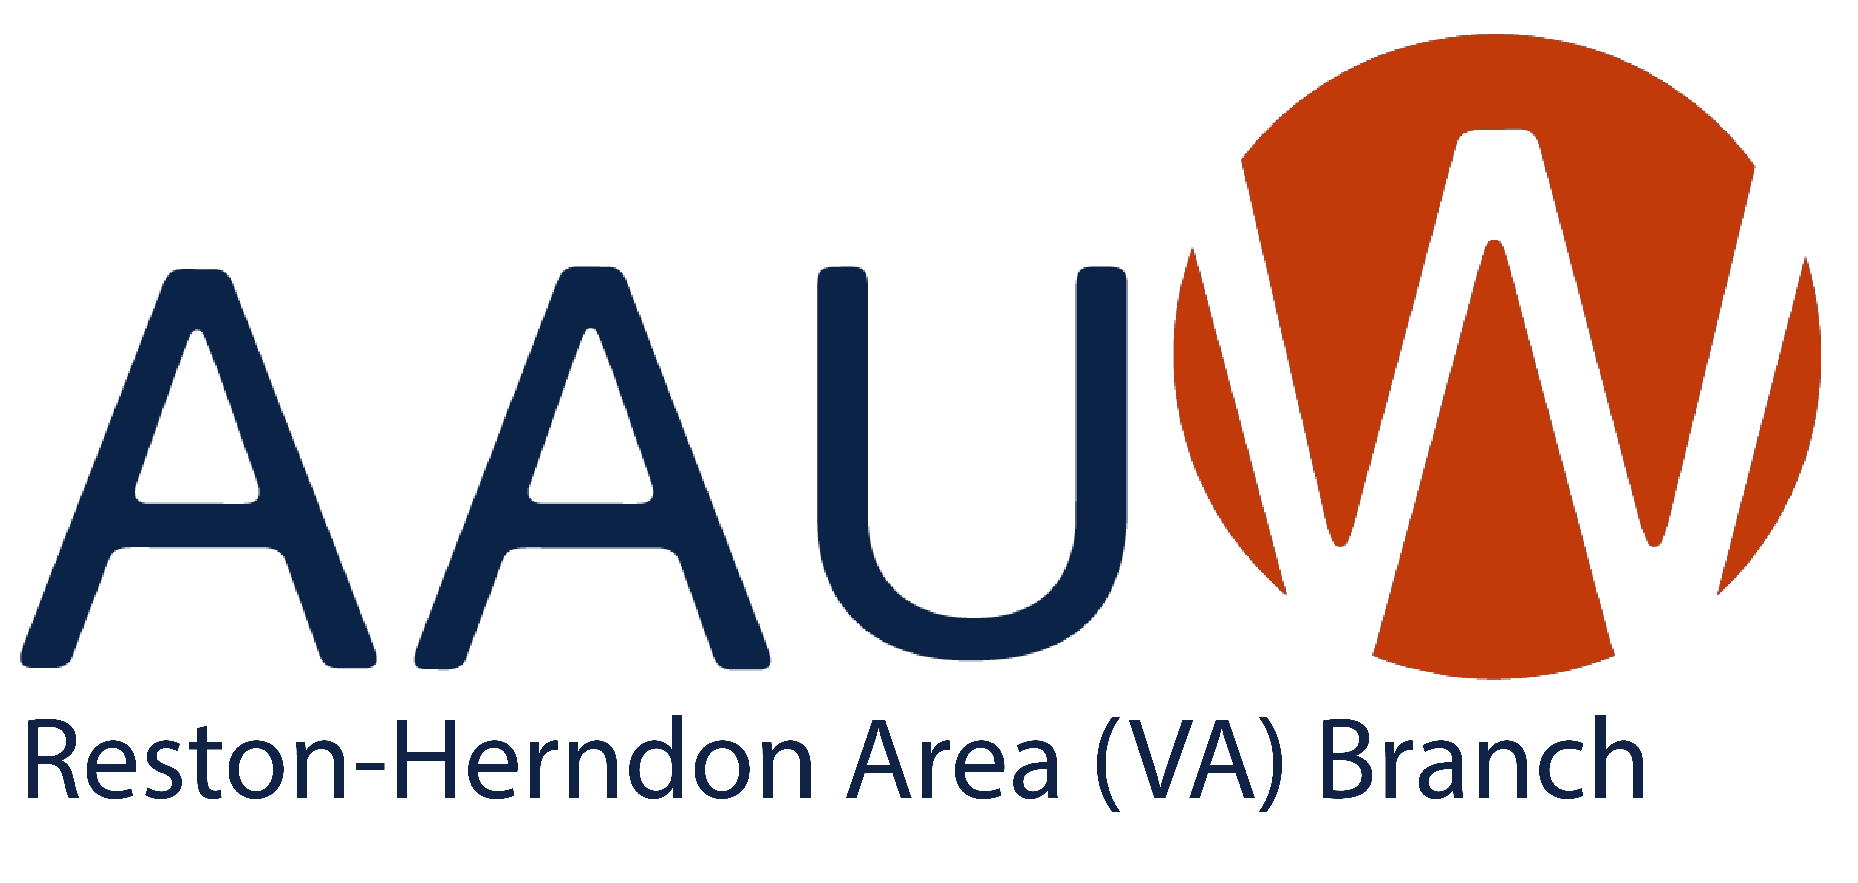
NEWSLETTER
January 2026
Public Policy
On February 5th we will have our annual lobby day to put our AAUW priorities in front of our state legislators. This looks like a good year to get things passed! So please join us.
Many of us go to Richmond the night before because we start so early on the 5th, but that’s up to you. If you want to stay in the hotel where many AAUW women from around the state stay, the link to reserve a room at Hampton Hilton Inn & Suites Richmond, 700 East Main Street is https://group.hamptoninn.com/iq67qw . There will be a meeting and dinner just with AAUW members in the hotel at 5:30 to meet others and to discuss issues and logistics for the next day.
On the morning of the 5th, we will meet at 8:00 at the Senate Education & Health Committee where we will get a briefing with talking points on the issues and another chance to ask questions. We will go to assigned offices with a partner to deliver our messages. You will get a chance to meet with your delegates’ offices as well as one or two from around the state.
We’ll be done by 1:00 or so and many of us will meet up for lunch before heading home.
AAUW VA needs some information from you to help organize the day. Please click the Google Doc below. (Remember you may have a new Delegate in February 2026. Check here if you are unsure.)
https://docs.google.com/forms/d/e/1FAIpQLSd-X3fKYDt_m6ixrW7bDbznCshvMrDzDCF7XjzL2x5GwNk0ZA/viewform?usp=dialog

Book Group
Carla Heymsfeld and Alyse Goldman
Book Group meets on the fourth Wednesday of the month at 1:15pm the Lake Anne Used Bookstore in Reston. Members meet for lunch before at Café Montmartre at Noon.
January 28: Be Ready When Luck Happens, by Ina Garten ere, for the first time, Ina Garten presents an intimate, entertaining, and inspiring account of her remarkable journey. Ina’s gift is to make everything look easy, yet all her accomplishments have been the result of hard work, audacious choices, and exquisite attention to detail. In her unmistakable voice (no one tells a story like Ina), she brings her past and her process to life in a high-spirited and no-holds-barred memoir that chronicles decades of personal challenges, adventures (and misadventures) and unexpected career twists, all delivered with her signature combination of playfulness and purpose.

February 25: Strong Poison, by Dorothy L. Sayers (Golden Age mystery) This is the first of the Lord Peter and Harriet Vane novels. I know Janine would like to read Gaudy Night, but it’s the last in the series and it’s very long. Dorothy Sayers is interesting also-a very intelligent woman, but there are hints of the prejudices of her times in her novels. So both the story and the author would make for a good discussion.

March 25: The Attenbury Emeralds, by Jill Paton Walsh (Golden Age mystery by contemporary author) Jill Paton Walsh was asked by the estate of Dorothy Sayers to write more Lord Peter/Harriet Vane novels. I’ve enjoyed all of these, and I thought it would be interesting to see what people think of this modern interpretation of these characters and their story.

April 22: The Mitford Affair, by Marie Benedict (Historical Fiction) It seems the Mitford sisters are having a moment, and we’ve read several Marie Benedict novels. I haven’t read this, but it’s about how one Mitford sister tries to counteract her Nazi-loving sister. I think there’s a movie around now about these sisters.

May 27: Geisha: A Life, by Mineko Iwasaki (Biography) The life story of a Geisha. Since I know nothing about this, I thought it would be fascinating to read, and lead to good discussion.

June 24: The Life Impossible, by Matt Haig. (Contemporary Fiction) A retired math teacher inherits a Mediterranean island house and uncovers a strange truth about her friend's life, forcing her to confront her past. The review says: "Filled with wonder and wild adventure, this is a story of hope and the life-changing power of a new beginning.” I thought, if this is our last book group meeting, it would be nice to end on an uplifting novel.

Diversity, Equity, Inclusion and Belonging
Patty Hagan
Save the Date
Join us on Saturday, March 21, at 3p.m. at the North County Government Center in Reston for an unforgettable event! We’re happy to announce that Delegate Irene Shin will be our speaker for Women’s History Month. She has represented Fairfax County’s 8th District since 2022. This includes Herndon and extends to Route 50 in the Chantilly area.
Delegate Shin is a long-time community organizer and activist. As the child of Korean immigrants, she learned that America’s promise was something that most immigrant families had to fight for. And she continues to fight now as a state delegate for her constituents.
Come learn what Delegate Shin is working on for us, and bring your questions too!
Mark your calendars now—you won’t want to miss this!

The recent National DEIB officers meeting focused on difficult conversations. They may be on race, DEI, politics, etc. Topics that we might avoid or not know how to manage when we find ourselves in one. It’s about talking “with” someone, rather than talking “to” someone with whom we have a difference. There isn’t any one, right way to have these conversations be useful. Here are some suggestions from the meeting.
1. Increasing understanding, not persuasion. This suggestion is easy to say but hard to actually put into practice. That said, it may be the most important. Entering a discussion, particularly about difficult topics, will likely get stuck if the goal is to convince others of one’s point of view because, after all, we know “the” answer. This tendency is quintessentially human and comes with good intent, but it can present a barrier to genuine communication.
2. “Facts” are often in the eyes of the beholder. Be cautious about claiming that something is a “fact.” We all obtain information from different sources and base our understanding on this input. No information source should be rejected out of hand. Remember, it is often not the “facts” that are most salient, but rather which questions were, or were not, asked. Both “facts” and “feelings” are genuine ways of knowing.
3. Listen fully. Listen and respect others when they are talking. Allow others to f inish articulating their thought before responding. You may wish to set gentle time limits to ensure everyone has a chance to speak.
4. Participate with curiosity. Ask questions because you truly want to understand, not just to make your own point. Curiosity shifts conversations from debate to discovery.
5. Speak from your own experience. Using “I” statements rather than generalizations can be helpful. Sharing your own perspective invites connection; assuming others’ experiences often shuts it down.
6. Notice nonverbal signals. Body language and tone often communicate more powerfully than our words. Be mindful of the messages you send and receive. They often speak louder than words!
7. Silence is okay. Pauses aren’t mistakes—they’re moments to think, reflect, and process, especially when the topic is sensitive or unfamiliar.
8. Remember that differences are normal. Fully appreciate that it’s the nature of human beings to have different opinions and perspectives. When have you participated in a group or family setting where everyone agrees 100%? What would be the value of a discussion about a topic tat already has universal agreement?
9. Consider what confidentiality means. Groups often ask for confidentiality, but expectations may differ. Is it acceptable to talk to a spouse or close friend about the discussion? Should names be omitted? Agreeing on a realistic definition helps avoid confusion. Acknowledge that we are all in this together and, just like when we were in school, truly listening to other perspectives can enrich our lives and the lives of others.
[This excellent summary is from Meg Tuccillo, AAUW Virginia DEIB VP]

On January 19th we honor and celebrate the life of the Rev. Dr. Martin Luther King, Jr. His leadership of the civil rights movement through peaceful non-violence resulted in numerous laws which changed how this country legally treated people of African descent and other marginalized people. Check out some of the great events celebrating Dr. King at the Reston Community Center: January 17, 18, 19 (Saturday, Sunday and Monday)
- Community Service Projects
- Akua Allrich Presents “New Moon Rising”
- Reston Community Orchestra “Tribute to Rev. Dr. Martin Luther King Jr.”
- Reston Dr. Martin Luther King Jr. Birthday Celebration Keynote Address by Dr. Eddie Glaude Jr. Keynote Address and Community Luncheon
- MLK Birthday Celebration Especially for Youth

And February is Black History Month. The theme this year is “A Century of Black History Commemorations.” Dr. Carter G. Woodson planned the first Negro History Week in 1925. His contemporary, W. E. B. Du Bois stated, “He [Dr. Woodson] literally made this country...recognize and celebrate each year a week in which it studied the effect which the American Negro has had upon the life, thought and action in the United States. I know of no other man who in a lifetime has unaided built up such a national celebration." [chrome-extension://efaidnbmnnnibpcajpcglclefindmkaj/https://asalh.org/wp-content/uploads/2024/10/2026-Black-History-Theme-Executive-Summary.pdf]
During the Bicentennial year, President Gerald Ford was the first president to issue a proclamation about Black History Week. Ten years later, Congress passed a law designating February as Black History Month. It’s a time to learn about the numerous and important contributions of people of African descent to this country. We encourage our members to delve into something they don’t know about Black History. And for many of us, that part of history sadly wasn’t focused on in our education.

LUNCH BUNCH
Lunch Bunch is taking a break in January but will return in February.

PROGRAMS

AAUW-VA All District Program
January 22, 2026
7:00 P.M. via Zoom
Join AAUW-VA members from around the Commonwealth to hear from Bonnie Svrcek, Executive Director of the Virginia Women’s Municipal
Leadership Institute. The Institute is a professional education program developed by Virginia Women Leading Government and academic partners to provide connections, content, tools, and opportunities for

Topic: Virginia Women’s Municipal Leadership Institute
Time: Jan 22, 2026 07:00 PM Eastern Time (US and Canada)
Join Zoom Meeting
https://us06web.zoom.us/j/84656305779?pwd=Ccb3fbCSUbBa1V4YNrhCtejiqdlb33.1

2025-26 Reston Herndon Area AAUW Leadership

President Janine Greenwood
VP Finance Ruth Ruttenberg
VP Membership Vacant
VP Program Vacant
Secretary Stephanie Abbott
AAUW Funds Stephanie Abbott
Adopt-a-Spot Fran Lovaas
Cultural Arts Carol Flicker & Joyce Senger,
Book Group Alyse Goldman & Carla Heymsfeld
Diversity, Equity, Inclusion Patty Hagan
Newsletter Vacant
Public Policy Shyamali Hauth
Website Samantha Polon
Zoom and Updates Janine Greenwood

AAUW Diversity Statement: In principle and in practice, AAUW values and seeks an inclusive membership, workforce, leadership team, and board of directors. There shall be no barriers to full participation in this organization on the basis of age, disability, ethnicity, gender, gender identity, geographical location, national origin, race, religious beliefs, sexual orientation, and socioeconomic status.

Vision: Equity for all.
Values: Nonpartisan, Fact-based, Integrity, Inclusion and Intersectionality

