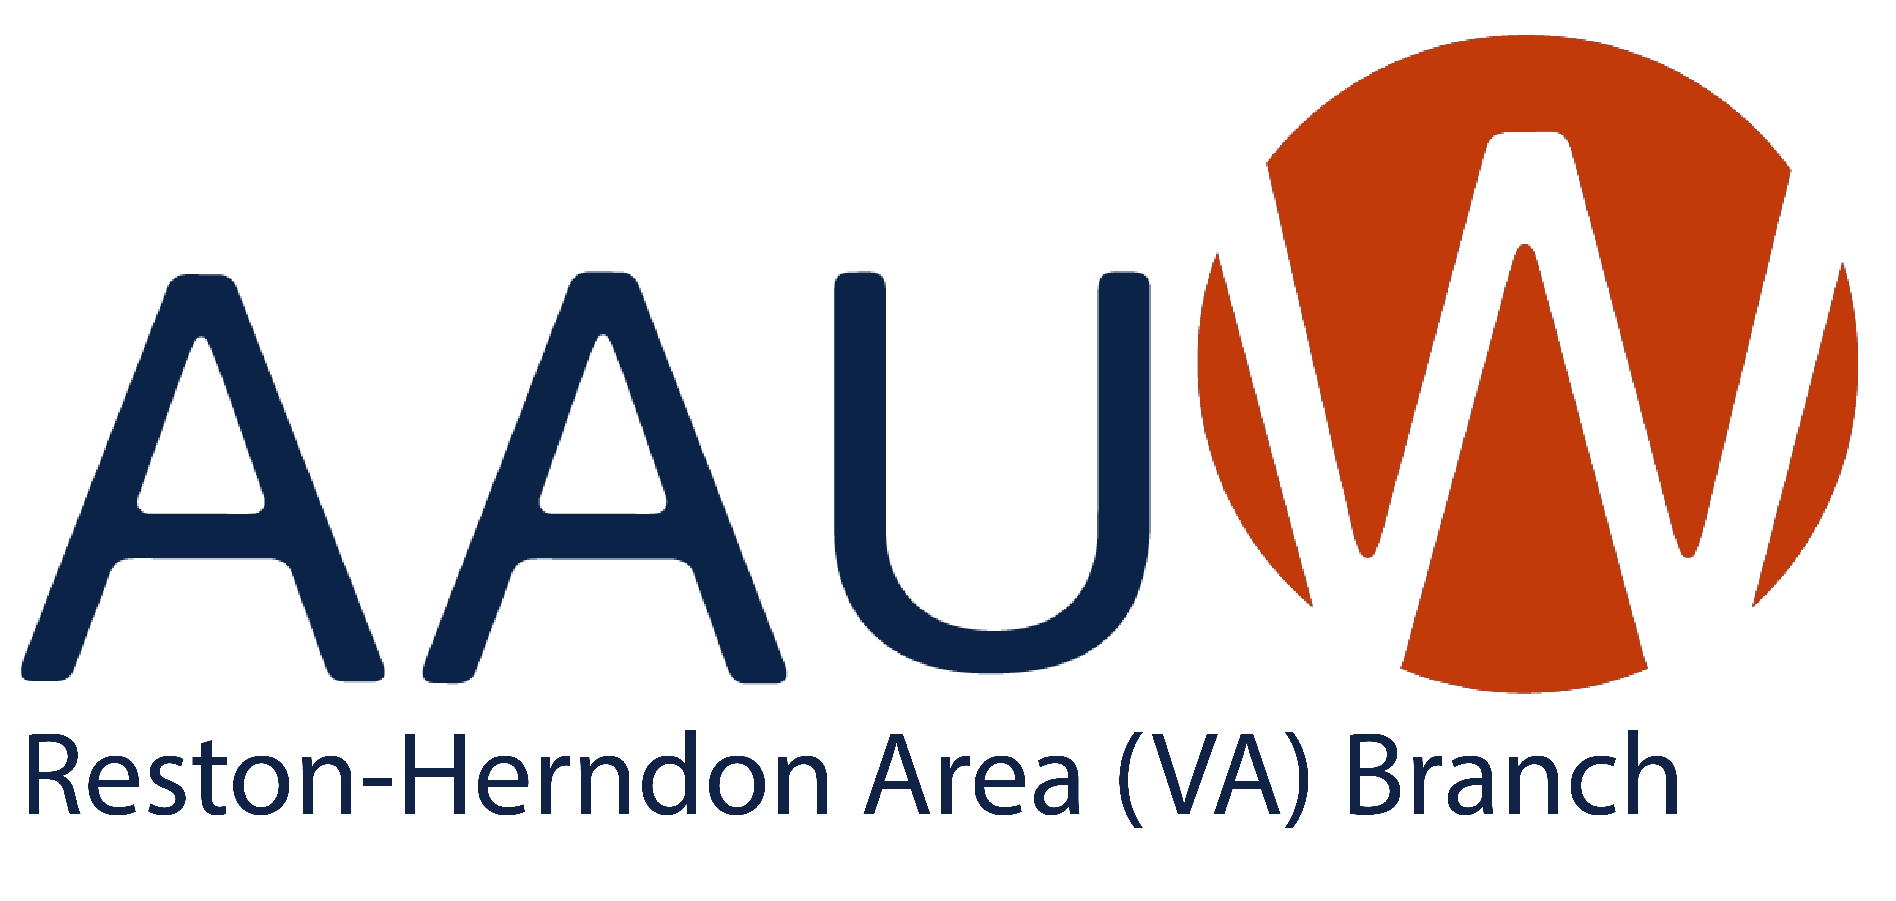
October 2025 Newsletter

Check out all the exciting things happening in our Branch and with other AAUW Branches!
Janine Greenwood, President

BRANCH PROGRAMS AND EVENTS

POSTCARDS Monday, September 29
We have postcards to encourage voter registration and voting in the Virginia General Election and have ordered 120 addresses.100 down 20 to go. Join us for our last group postcard writing event:
September 29 at 11:30 AM in the Café Montmartre patio.

Special R-H Community Program, Saturday, October 4
Join Reston-Herndon AAUW for a Conversation with Hall Baldwin, Director of Reston Regional Library via Zoom on October 4 at 4:00. She will speak on books bans, funding and other challenges facing the Reston branch and all libraries and provide an update on the new library. Register here for our Zoom meeting on Saturday, October 4 at 4PM: https://us02web.zoom.us/meeting/register/WFdMyB3XTcirSDG0TJG_jg

SAVE THE DATE for a Reston-Herndon Branch program with Fairfax Schools Superintendent Michelle Reid at North County Government Center on Friday, November 21 at 5PM and on Zoom. With everything in the news about education you won’t want to miss this event. Details in the October newsletter.

R-H BOOK GROUP Wednesday, October 22
Celebrate our Foremothers at a Special Book Group on Wednesday, October 22
The Indigo Girl by Natasha Boyd : Eliza Lucas is sixteen years old when her father leaves her in charge of their family's three plantations in rural South Carolina and then proceeds to bleed the estates dry in pursuit of his military ambitions. Soon her family is in danger of losing everything.
Upon hearing how much the French pay for indigo dye, Eliza believes it's the key to their salvation. Everyone tells her it's impossible, but she did it and indigo dye became one of the largest exports out of South Carolina. When she passed away in 1793, President George Washington served as a pallbearer at her funeral.
The book is a fast and compelling read.
Book group meets at 1:30 and many of us gather before at noon Café Montmartre to enjoy lunch. Join us!

AAUW-VA PROGRAMS AND EVENTS

AAUW-VA Northern District, Tuesday, October 14
The first virtual All-District meeting for this year will be on October 14, 2025 at 7 pm: “One Person, One Vote: The National Popular Vote vs the Electoral College.” This program will be presented by Jane D. Newell, Greater Richmond Branch (GRAAUW) Finance Officer, and Director of Transformation for the League of Women Voters of Virginia (LWVVA). Five times in our history, the U.S. Presidential candidate with the most popular votes was not elected. That’s because the people do not elect the President; the Electoral College does. Jane will provide a fascinating program on the history of the current system and the National Popular Vote Interstate Compact to abolish the Electoral College, which the LWVVA is supporting.

AAUW Falls Church Thursday, November 6
We are writing as Co-VPs for Program for AAUW Falls Church to give you information about a branch program we are hosting in November. Our branch recently discussed the fact that misogyny is thriving and women’s advancement is stalling. That conversation prompted us to develop a two-part community forum Healing the Gender Divide in the Era of Pervasive Social Media. The forum provides research on widespread attitudes that directly harm AAUW priorities: equality, individual rights and social justice; economic security, and education.
The first forum will address the state of men and the state of women in our society, particularly how misogyny affects gender equity and the power of social media in reinforcing harmful gender attitudes. A representative of Equimundo https://www.equiundo.org, (a research organization which recently published The State of American Men 2025) will discuss the complex crisis of boyhood and manhood. A representative of Center for American Progress, Inclusive Economy https://www.americanprogress.org will focus on the "state of women" and the impact of misogyny and corrosive social media on the lives and livelihoods of women. The first Community Forum will be held November 6, 2025, 7:00 - 9:00 PM at Mary Ellen Henderson Middle School, Falls Church.

AAUW-VA Conference, April17-18 2026
The Northwest Branches (Greater Richmond, Winchester, and Fredericksburg Area) cordially invite you to the 101st AAUW-VA Conference, at the Drury Plaza Hotel Richmond, 11049 West Broad Street, Glen Allen, VA 23060.
Join us for afternoon tours and evening entertainment on Friday, April 17, 2026. Then on April 18, we'll spend the day together with: Interesting speakers, Informative panels,
Catered lunch, Irresistible raffle baskets to support AAUW Greatest Needs Fund
You can make reservations at the Drury Plaza Hotel by visiting the following link:
https://www.druryhotels.com/bookandstay/newreservation/?group no=10150185
OR CALL 1-800-325-0720 and reference your group number, 10150185, to make your reservation.
(The default dates may show as April 16 – April 20; just adjust the dates for your preference.)
To get the group rate, be sure to reserve your room by Sunday, March 15, 2026. Reservations made after this date will be subject to prevailing rates and availability.

R-H Branch Membership Matters
Welcome to our new member Devon Harvey in Oak Hill.
Our long-time and very active member Judi Polizzotti had an accident while traveling. She is now in rehab and will be home in a few days. You can send cards to: Judith Polizzotti, 11776 Stratford House Place, Reston VA 200190.

Early Voting has begun for the Virginia Election at the North County Government Center. Don’t forget to vote! The whole country is watching this Virginia election.

